**Practical No: 3** Ninad Karlekar 22306A1012 Date: 08/05/2023

**Aim: Configure IP SLA tracking and path control topology.**

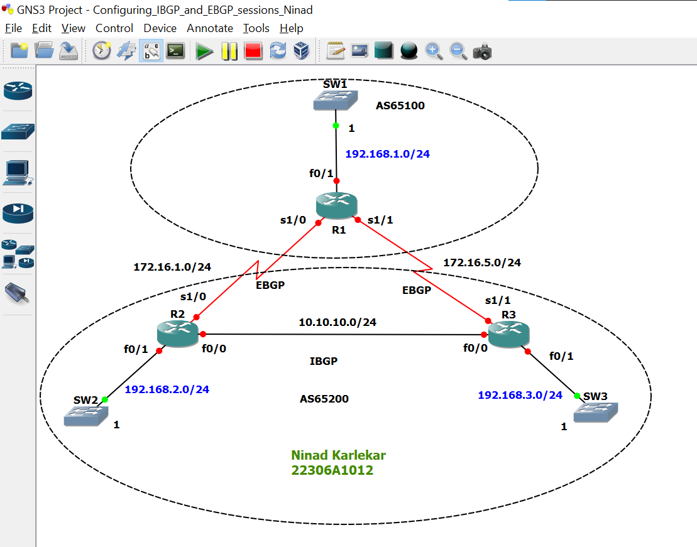

**Step 1: Configure IP addresses on the given routers**

**R1:**

R1#conf t

R1(config)#int f0/1

R1(config-if)#ip add 192.168.1.1 255.255.255.0

R1(config-if)#no sh

R1(config-if)#

R1(config-if)#int s1/0

R1(config-if)#ip add 172.16.1.1 255.255.255.0

R1(config-if)#no sh

R1(config-if)#

R1(config-if)#int s1/1

R1(config-if)#ip add 172.16.5.1 255.255.255.0

R1(config-if)#no sh

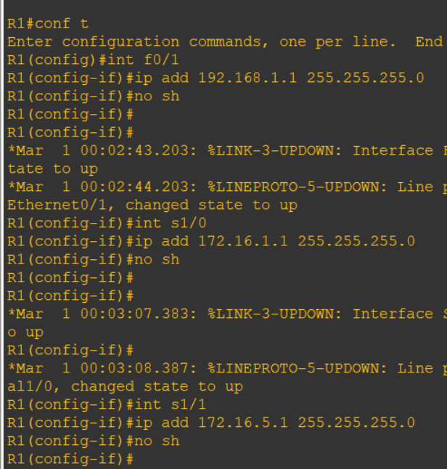

**R2:**

R2#conf t

R2(config)#int f0/0

R2(config-if)#ip add 10.10.10.2 255.255.255.0

R2(config-if)#no sh

R2(config-if)#

R2(config-if)#int f0/1

R2(config-if)#ip add 192.168.2.2 255.255.255.0

R2(config-if)#no sh

R2(config-if)#

R2(config-if)#int s1/0

R2(config-if)#ip add 172.16.1.2 255.255.255.0

R2(config-if)#no sh

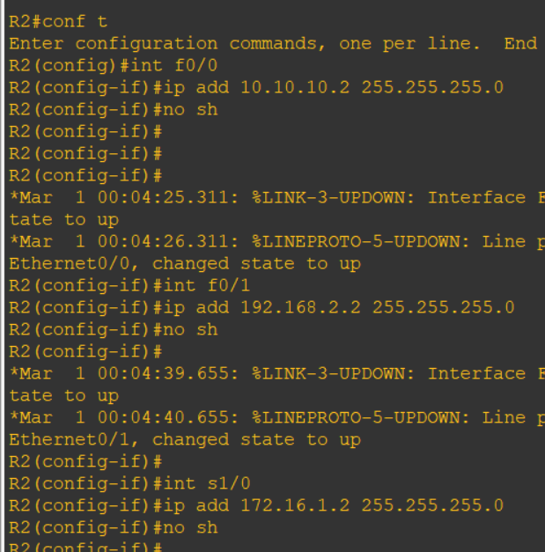

**R3:**

R3#conf t

Enter configuration commands, one per line. End with CNTL/Z.

R3(config)#int f0/0

R3(config-if)#ip add 10.10.10.3 255.255.255.0

R3(config-if)#no sh

R3(config-if)#

*Mar 1 00:05:06.839: %LINK-3-UPDOWN: Interface FastEthernet0/0, changed state to up

*Mar 1 00:05:07.839: %LINEPROTO-5-UPDOWN: Line protocol on Interface FastEthernet0/0, changed state to up

R3(config-if)#

R3(config-if)#int f0/1

R3(config-if)#ip add 192.168.3.3 255.255.255.0

R3(config-if)#no sh

R3(config-if)#

*Mar 1 00:05:20.271: %LINK-3-UPDOWN: Interface FastEthernet0/1, changed state to up

*Mar 1 00:05:21.271: %LINEPROTO-5-UPDOWN: Line protocol on Interface FastEthernet0/1, changed state to up

R3(config-if)#

R3(config-if)#int s1/1

R3(config-if)#ip add 172.16.5.3 255.255.255.0

R3(config-if)#no sh

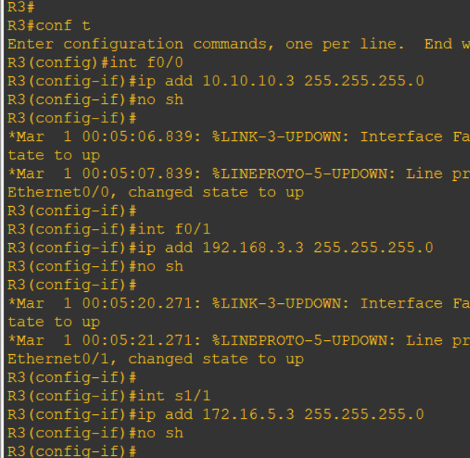

**On all routers:**

do sh ip int br | include up

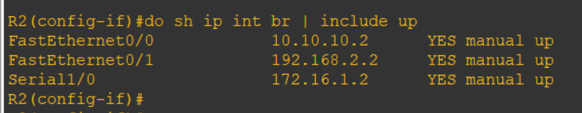

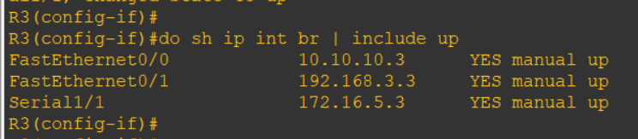

**Step 2: Configure IRP in autonomous system 65200**

**R2:**

R2(config-if)#router ospf 1

R2(config-router)#network 10.10.10.0 0.0.0.255 area 0

R2(config-router)#network 192.168.2.0 0.0.0.255 area 1

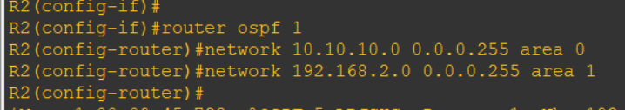

**R3:**

R3(config-if)#router ospf 1

R3(config-router)#network 10.10.10.0 0.0.0.255 area 0

R3(config-router)#network 192.168.3.0 0.0.0.255 area 2

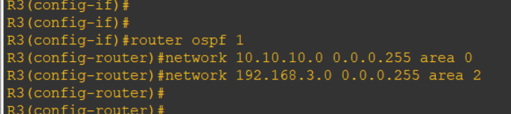

do ping 192.168.2.2

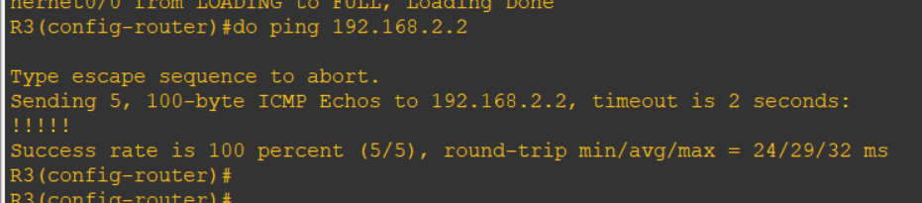

**Step 3: IBGP & EBGP configuration**

**R1:**

R1(config)#router bgp 65100

R1(config-router)#network 192.168.1.0

R1(config-router)#network 172.16.1.0 mask 255.255.255.0

R1(config-router)#network 172.16.5.0 mask 255.255.255.0

R1(config-router)#neighbor 172.16.1.2 remote-as 65200

R1(config-router)#neighbor 172.16.5.3 remote-as 65200

R1(config-router)#do sh ip route

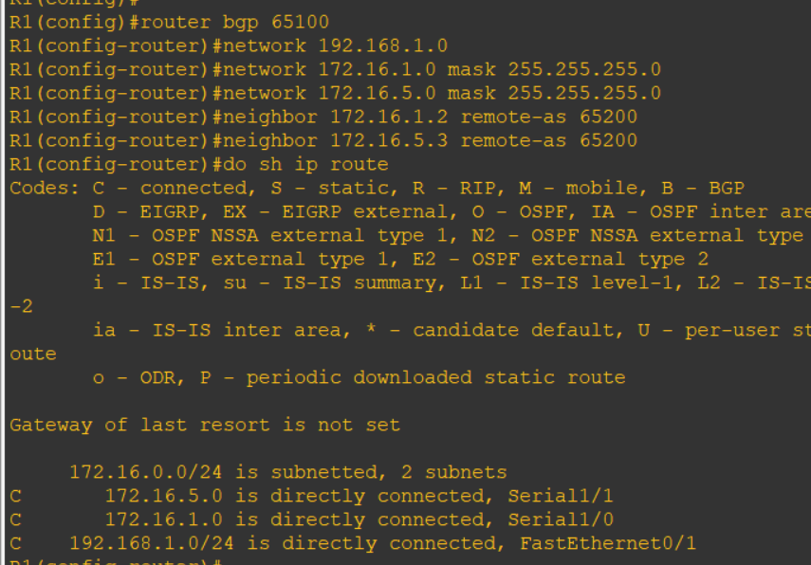

**R2:**

R2(config-router)#router bgp 65200

R2(config-router)#redistribute ospf 1

R2(config-router)#network 172.16.1.0 mask 255.255.255.0

R2(config-router)#neighbor 172.16.1.1 remote-as 65100

R2(config-router)#neighbor 10.10.10.3 remote-as 65200

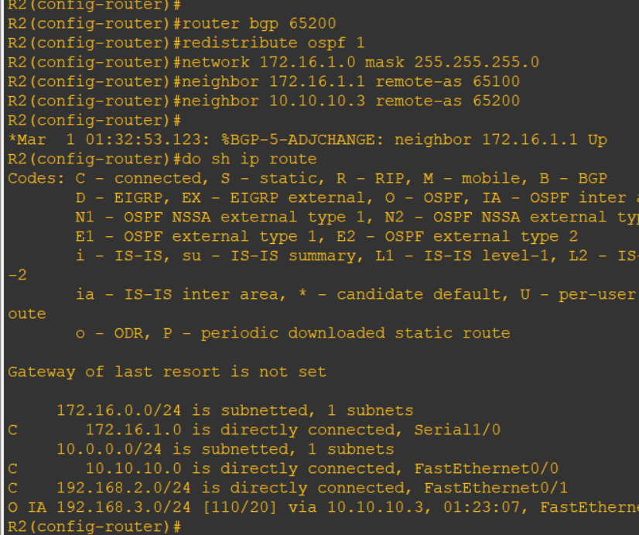

**R3:**

R3(config-router)#

R3(config-router)#router bgp 65200

R3(config-router)#redistribute ospf 1

R3(config-router)#network 172.16.5.0 mask 255.255.255.0

R3(config-router)#neighbor 172.16.5.1 remote-as 65100

R3(config-router)#neighbor 10.10.10.2 remote-as 65200

R3(config-router)#do sh ip route

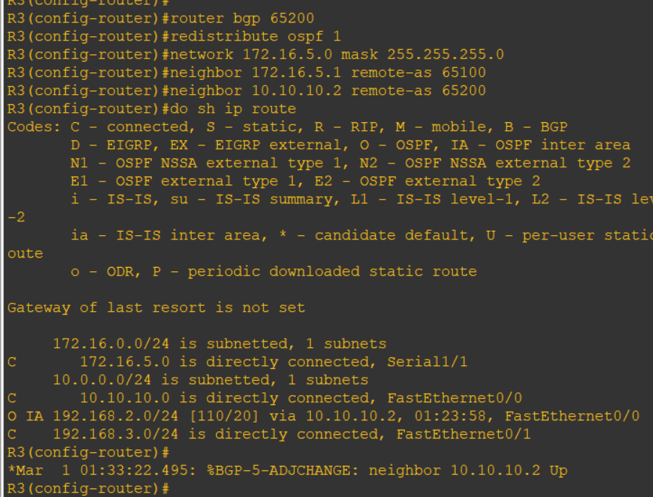

**R1:**

do ping 192.168.3.3

do ping 192.168.2.2

